Name: Marks: .

|  |  |  |  |  |  |  |  |  |  |  |
| --- | --- | --- | --- | --- | --- | --- | --- | --- | --- | --- |
| No. | 1 | 2 | 3 | 4 | 5 | 6 | 7 | 8 | 9 | 10 |
| Marks | 3 | 2 | 2 | 2 | 4 | 10 | 4 | 10 | 4 | 14 |
| Get |  |  |  |  |  |  |  |  |  |  |

1.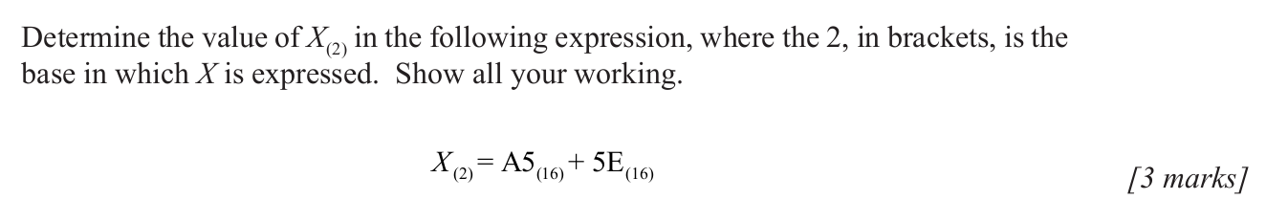

2.

3.

4.



5. 

6. 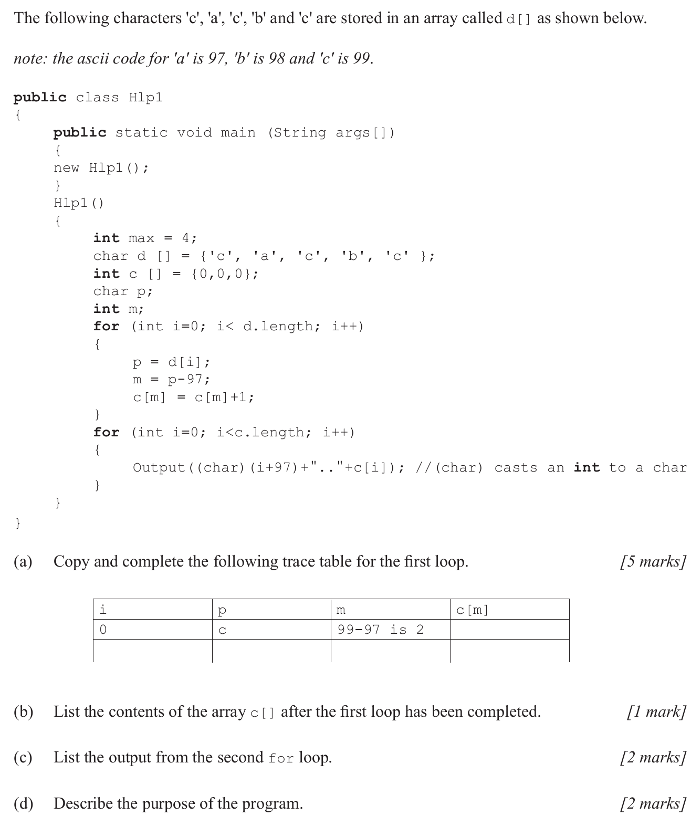

7.

8.

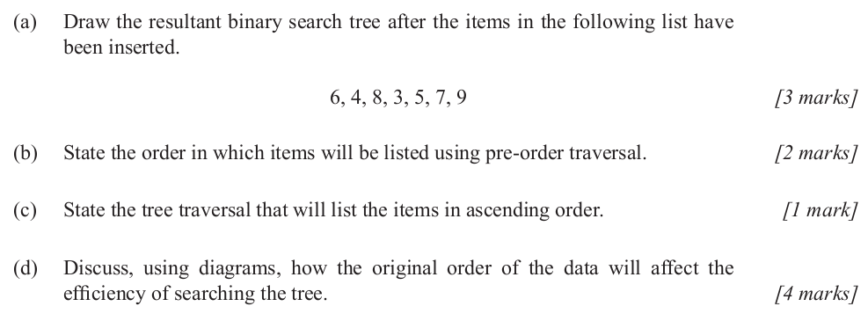

9. 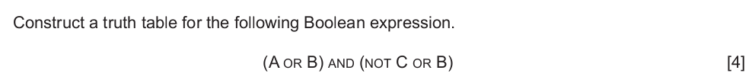

10.